Step Smart
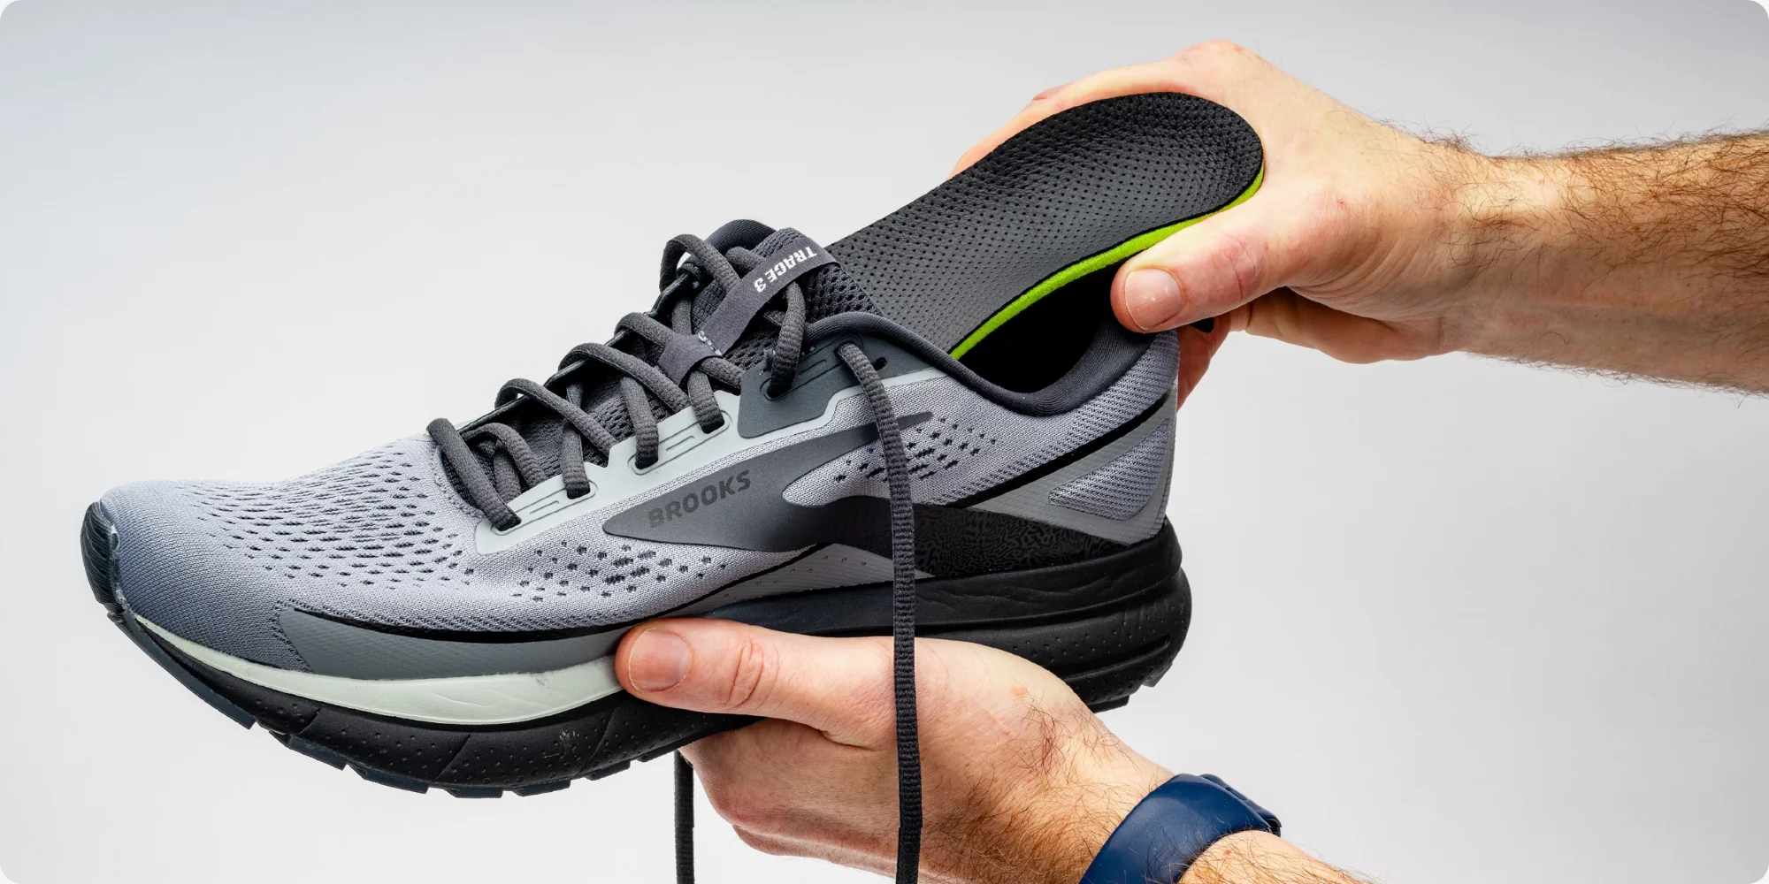
Injury Preventive Insoles
Jayme Greer | Evan Bohler | Sophie Miller | Charlie Whittleman

PROBLEM AND SOLUTION OVERVIEW
Many athletes suffer injuries due to improper foot posture, leading to inflammation, pain, and setbacks. Some injuries may force athletes to pause or even end their training or careers. According to the American Academy of Orthopedic Surgeons, 25% of sports injuries are foot and ankle related. We aim to design a solution that corrects poor placement and prevents injuries before they happen. By tracking foot placement and pressure in real time through sensors in insole inserts and connecting that data to a phone and smartwatch app, athletes could correct their movement before injury happens. Thin inserts with sensors on main pressure points allow for comfort while keeping typical movement undisturbed like chunky inserts might do. The data is displayed on apps in readable and understandable graphs and tables.

DESIGN RESEARCH GOALS, STAKEHOLDERS, AND PARTICIPANTS
We conducted our research by individually interviewing three participants across different age ranges and sports. We conducted these interviews within a week in a manner that felt most comfortable to the individual participant to ensure they felt at ease to answer our questions. We wanted to individually interview people in order to get detailed responses from participants to ensure we found key features for our design. By interviewing our diverse group of participants, we aimed to gain varied perspectives on habits, injury prevention, and preferences. We asked about their history with joint issues, preferred tracking methods, and key features they would want in an app to ensure our design meets their needs
Participants
Participant 1 is a manager within ITS that is an active runner and cyclist. He just turned 50 this year and has been running marathons and triathlons for over two decades. The interview took place face to face, where we discussed his experience with similar devices, past injuries related to running, and overall desires for a tracking device. Most notably, he mentioned that most runners are very particular about how their shoes feel.
Participant 2 is a dance instructor at a local studio with over 15 years of dance experience before becoming a teacher. Now in her 30s, she has been instructing for 14 years and also works at Weissman Costumes in St. Louis, giving her a broad perspective on dancers' needs. The interview took place in the office of the dance studio where both she and the interviewer work. An insight from the conversation was her comparison of our product to an Apple Watch and Fitbit. This suggests an opportunity to explore how these devices present their data, their price points, and what users expect from similar products.
Participant 3 was an SIUE D1 dancer. She is currently in her early 20’s, but started dancing in middle school. Her senior year of high school she won state for her routine. After being on her schools’ dance teams for eight years, she stepped down from dancing last year to focus on her schoolwork. The interview took place over a FaceTime call where she was in a comfortable and familiar place. She was very adamant about the various types of shoes she wore in dance and how different sensors would be beneficial for the differing shoes.

DESIGN RESEARCH RESULTS AND THEMES
Theme 1: Sensor Adaptability
Athletes across a broad range of sports, have different movement patterns and footwear needs. Runners experience constant high impact on joints, while dancers deal with more variability on their joint placement and pressure. Additionally, different sports require specific footwear, and some need multiple types of shoes within a sport itself. Given this variability, our product must be adaptable to meet the specific needs of athletes and sports. This adaptability was a key consideration in our initial design phase, and user feedback has reinforced its importance – particularly the preference for clip-on sensors. Since we anticipated this need, ensuring sensor flexibility aligns well within our design scope and does not present problems.

Theme 2: Sensor Durability and Usage Length
Athletes often engage in their sport for several hours per session, multiple times a week, placing significant stress on the durability of our product. The sensor must withstand high-impact movements, have long battery life, and be resistant to water exposure from sweat and rain. While this specific challenge was not a primary focus in our initial discussions, it is an expected consideration given the nature of athletic activities. Although we are still uncertain about the technology required to meet these durability needs, research into existing tracking devices shows that achieving these standards is feasible. Many fitness and performance tracking tools are already designed to endure similar conditions, providing a strong foundation for our approach.
Theme 3: Compatibility with Apps and Ease of Use
Athletes frequently use apps to track their fitness, health, and nutrition, making it essential for our product to provide easy to understand data visualization, intuitive tracking, and compatibility with existing platforms. A universal app where users can access all their performance data in one place would be a valuable tool, and integrating our data with preexisting fitness apps could enhance usability and streamline the user experience. Beyond compatibility, the app and sensor should be easy to navigate, with clear visual cues and intuitive design to reduce user frustration and ensure a smooth experience. While we have touched on this aspect in previous discussions, we recognize its importance and plan to prioritize it in development. Given our familiarity with app and device design, we do not anticipate significant challenges in implementing these features.

ANSWERS TO TASK ANALYSIS QUESTIONS
- Who is going to use the design?
  - Our target audience are athletes, coaches, fitness instructors, and people who exercise regularly. Ranging from all ages, anyone who is subject to joint injury due to physical activity can use our product.
- What tasks do they now perform?
  - Most perform stretches to prepare for their activity and wear specific shoes for their sport needs. While participating in their sport, they may use devices like FitBits, Apple Watches, or other activity tracking sensors, but these focus more on steps, heart rate, acceleration, etc.
- What tasks are desired?
  - The tasks desired for functions within our product vary vastly. Any tasks that include strenuous pressure on a person’s ankle would be desired for use of our product.
- How are the tasks learned?
  - Most athletes develop their skills through guidance from coaches, instructors, and peers by attending practices and training sessions. However, some physical activities, such as running and cycling, can often be self-taught. Many individuals learn these activities by researching techniques and best practices online, allowing them to improve independently without formal instruction.
- Where are the tasks performed?
  - These activities can take place in various settings, including homes, fields, studios, and other environments suited to the sport. Given the wide range of athletic disciplines, the location often depends on the individual’s lifestyle, preferences, and training needs.
- What is the relationship between the person and data?
  - Our design utilizes data that directly reflects a person's fitness and joint health. Sensors continuously track foot pressure as the participant wears the device throughout their daily routine. This data is then stored and accessible to the participant through a separate app.
- What other tools does the person have?
  - Different sports utilize various tracking devices, but common options include smartwatches like the Apple Watch and Fitbit. Some athletes also use sport-specific sensors, such as clip-on shoe sensors for runners. Based on our research, many apps track fitness metrics like steps and activity levels; however, monitoring foot pressure seems to be a more specialized and less commonly tracked aspect of performance.
- How do people communicate with each other?
  - Within our app, users would be able to communicate their data with either a coach and/or a doctor. This allows users to get the help they desire in order to fix their foot placement.
- How often are the tasks performed?
  - The frequency at which these tasks are performed differ for each person. It depends on how committed to their sport they are, but could be as frequent as multiple hours everyday. Also, this product could be used for tasks as simple as walking, in which case the person would be constantly performing their task.
- What are the time constraints on the tasks?
  - Our product needs to have a long battery life as the time a user would use our product could be all day. Ideally, we would want the user to charge the sensor while they are sleeping so it is at full battery for when they are on their feet all day.
- What happens when things go wrong?
  - Some key events we need to consider for when things go wrong are water-proofing the sensor. This is in case the user steps in water or the sensor gets wet, we need to ensure our product continues to record data accurately. Also, we must be mindful of medical data being stored on our app in case of a security breach. Confidential medical history or even showing which doctor the user goes to, is sensitive information we must protect.

PROPOSED DESIGN SKETCHES
Design 1: Mobile Foot Fitness App
This user-friendly app (shown in Figure 1) syncs with a sensor to import and display health and fitness data in an easy-to-read format using graphs, tables, and a visually appealing color scheme. It tracks user movements to assist with joint pain and is compatible with phones and smartwatches for convenience. The app provides instant activity reports, including foot rotation analysis, suggested exercises, and medical data, eliminating the need for multiple apps. Users can easily share their data with coaches and doctors for precise feedback and accurate diagnoses, ensuring optimal adjustments to prevent pronation and supination. Based on this, we can ensure that this design focuses on the following tasks: “use an app to see health and fitness data visuals,” “send health and fitness data to doctors and coaches,” “versatile for multiple activities,” and “know how one’s feet are positioned during activities.”
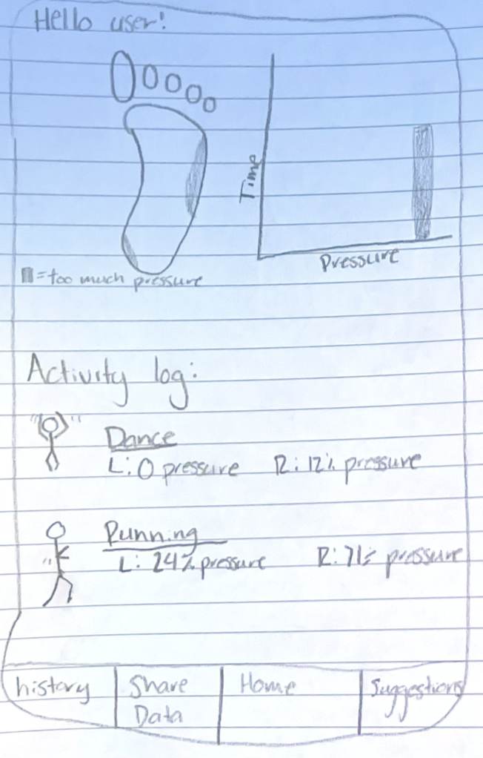
Figure 1. Mobile Foot Fitness App Sketch
Design 2: Lace Clip-On Sensor
This lightweight sensor (shown in Figure 2) clips onto shoelaces to track foot rotation, offering a non-invasive alternative to insole designs for those sensitive to changes in their footwear. Using a gyroscope and accelerometer, it monitors foot tilt without altering movement patterns. Its durable, waterproof casing ensures reliability in all weather conditions, while its external design makes it compatible with various activities, especially those requiring specialized footwear. Though slightly less precise than insole tracking, its unobtrusive nature allows athletes to comfortably wear it for extended periods without interference. Based on this, we can ensure that this design focuses on the following tasks: “comfortably wear tracking tools for long lengths of time,” “wear tracking tools in all weather conditions,” “versatile for multiple activities,” and “know how one’s feet are positioned during activities.”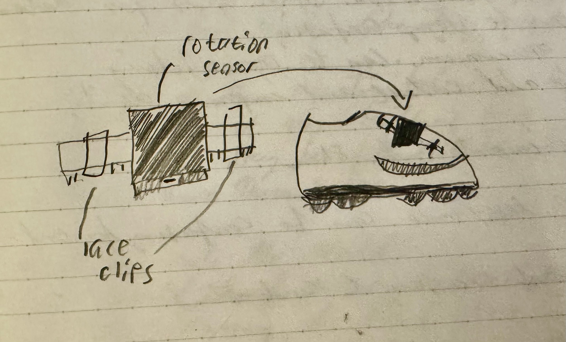
Figure 2. Lace Clip-On Sensor Sketch

Design 3: Full Insole Pressure Sensor
This full-length insole (shown in Figure 3) features built-in pressure sensors at key points of the foot, ensuring comfort while accurately tracking pressure distribution. The collected data syncs with a connected app, displaying intuitive graphs that help users monitor foot positioning and detect imbalances. Designed for durability and waterproofing, it functions like a standard sports insole, fitting various shoe types while withstanding different weather conditions. Its thin, cushioned design ensures long-term comfort, allowing users to wear it seamlessly without noticing any difference, while still gaining valuable insights into their foot alignment and movement patterns. Based on this, we can ensure that this design focuses on the following tasks: “comfortably wear tracking tools for long lengths of time,” “wear tracking tools in all weather conditions,” “use an app to see health and fitness data visuals ,” and “know how one’s feet are positioned during activities.”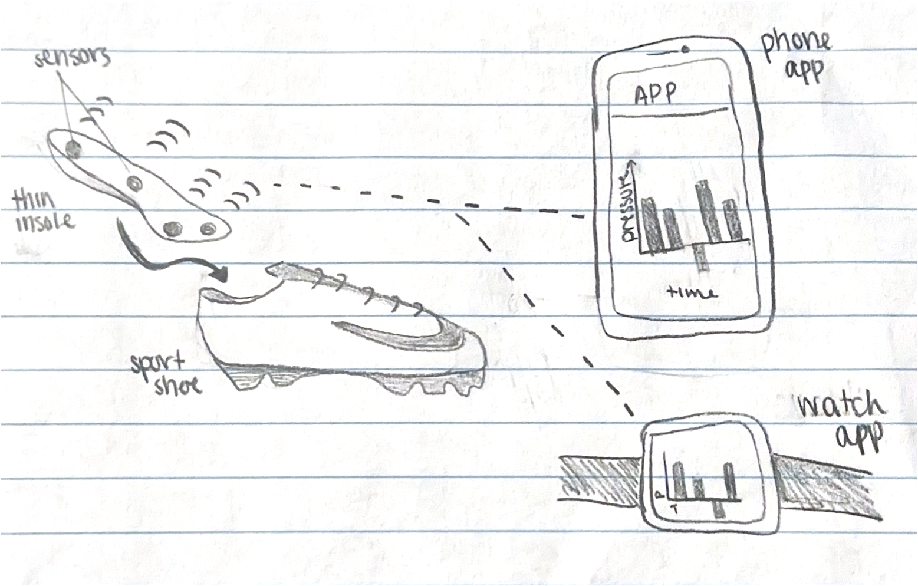
Figure 3. Full Insole Pressure Sensor Sketch

Design and Task Choice
We selected “Design 3: Full Insole Pressure Sensor” because it directly measures foot pressure, crucial for tracking overpronation and supination. It will be available in multiple sizes to accommodate various shoe types and sports, ensuring versatility and comfort. The insole seamlessly integrates with an app for real-time data tracking and analysis, providing clear insights through graphs and charts. Placed inside the shoe, it remains protected for durability and long-term performance. We chose the tasks “Know how one’s feet are positioned during activities” and “Use an app to see health and fitness data visuals” as these are the core functions of this product, as they allow users to assess and improve their stance, while features like waterproofing and comfort serve as valuable enhancements.

WRITTEN SCENARIOS
Task 1 Storyboard: Knowing how one’s feet are position during activities
Despite practicing for the past 6 months, Marco still feels significant joint pain after going for a run. He thought that it would get better as his technique improved, but there was still no progress. He brought it up to his physical therapist and was recommended Smart Step, the injury preventive insoles. Before his next run he slipped them into his shoes and then he set out. After returning home, he checked the Smart Step app on his phone. Overpronation! The inside of Marco’s feet were taking 80% of the impact while he was running. An insight from the app told him his ankles are buckling when his feet first strike the ground, and then they level themselves out before he lifts his feet again. Marco’s physical therapist was able to give him tips and drills for correcting his foot posture, and after a few weeks, he had perfect, proper pronation and no pain.
Task 2 Storyboard: Use an app to see health and fitness data visuals
Zen loves to run, she grew up running cross country and track throughout her educational career. She has been having ankle pain for the last few months and wants to fix this issue. Now Zen is not a data driven person. In fact, her subject of choice is history. She went to a specialist and they ran some tests then gave her papers filled with numbers. Zen became overwhelmed and unaware of how to decode her data. To fix this issue, she called her primary care doctor and asked what to do. Dr. Vork suggested Bluetooth smart insoles that connect straight to her phone and smart watch. Zen’s doctor explained how this app was user-friendly and displayed data in a way that is comprehensible. It showed where exactly on the foot too much pressure was being added and kept track of the pressure long-term via a graph. Zen quickly invested in these insoles and wore them constantly. She loved how the product constantly synced to her phone without any added steps. With this data readily available and easily understandable, Zen was able to work on her foot placement while she ran and has not suffered any more pain.

STORYBOARDS OF THE SELECTED DESIGN
Task 1 Storyboard: Knowing how one’s feet are position during activities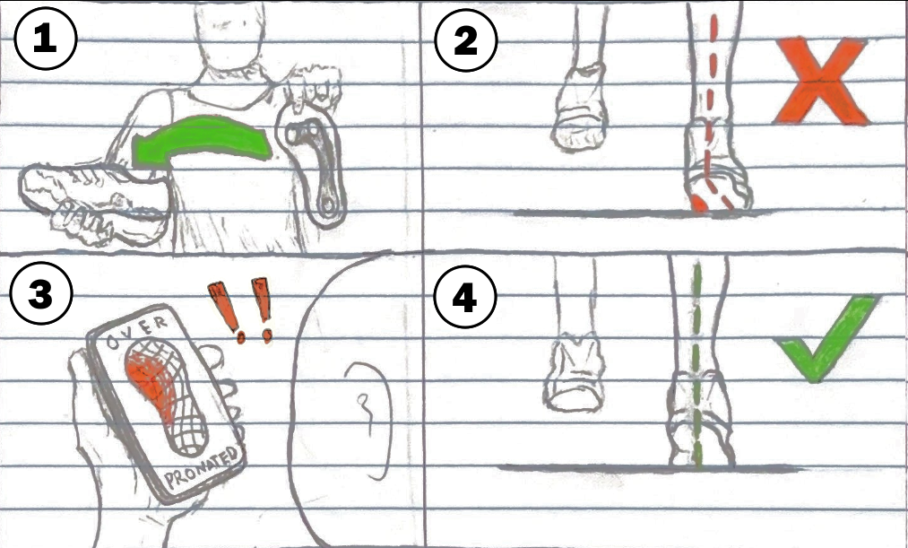
Figure 4. Task 1 Storyboard: Foot Position

Task 2 Storyboard: Use an app to see health and fitness data visuals
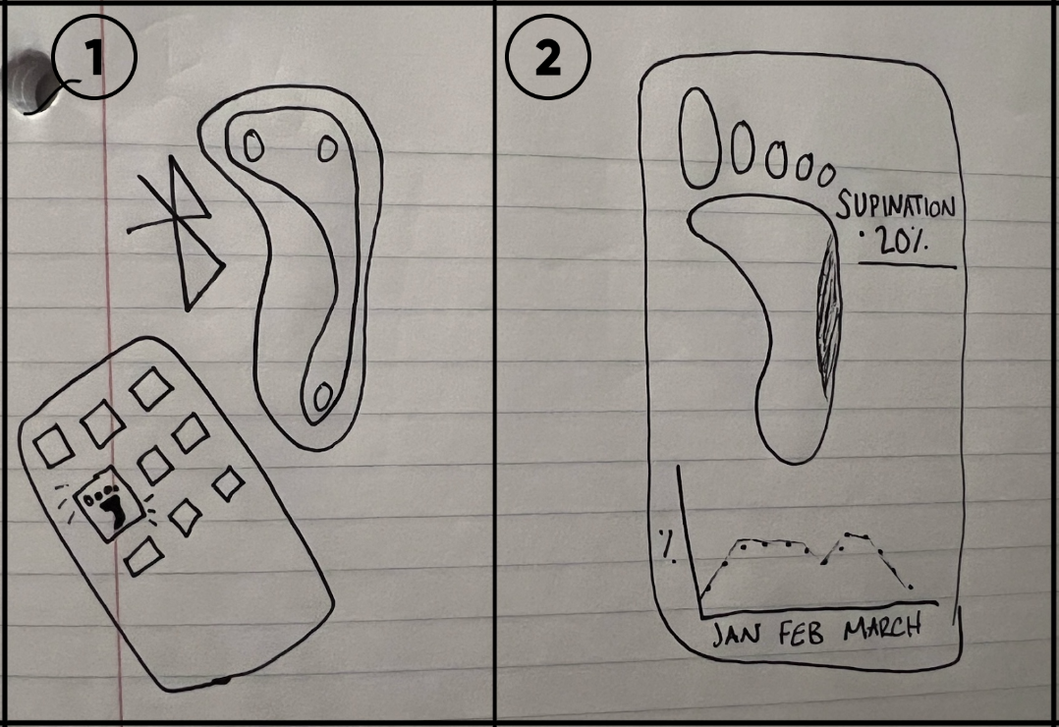
Figure 5. Task 2 Storyboard: Health and Fitness Visuals App

APPENDIX OF FEEDBACK SESSIONS AND USER RESEARCH
User Research Interviews
We interviewed a diverse mix of athletes to get an accurate measure of what’s needed for a foot pressure tracker. Here’s a quick look at our conversations:
Participant 1 (Runner, 50s):
- Ankle History: Experienced ligament damage to the left ankle due to high-intensity activity.
- Current Equipment: Uses running shoes along with a Strike Power Meter–a clip-on sensor that tracks acceleration, impact, and stride forces
- Activity Frequency: Engages in daily running and walking at moderate to heavy intensity.
- Product Preference: Prefers clip-on sensors over insoles due to comfort concerns.
- Preparation Routine: Performs dynamic leg stretches prior to activity.
- Desired App Features: Integration with other fitness apps (e.g., Apple Health) to consolidate data
Participant 2 (Dance Instructor, 30s):
- Ankle/Joint History: Experiences mild knee and hip pain, primarily when sitting or standing for extended periods.
- Current Equipment: Has used various footwear types including ballet shoes, tap shoes, and lightweight sneakers.
- Activity Frequency: Participated in dance classes 2-3 times a week (6-7 hours total) and now instructs for approximately 5 hours weekly.
- Product Preference: Open to both insoles and clip-on sensors, though already uses an Apple Watch for basic tracking.
- Preparation Routine: Performs thorough stretches, including specific ankle stretches with therabands.
- Desired App Features: Visual data representations (charts and graphs), distinct tabs for different classes, and comparison features for student averages.
- Price Sensitivity: Prefers a price point similar to or slightly lower than a Fitbit, particularly for bulk or class-use scenarios.
- Data Sharing: Values the ability to share data with instructors and healthcare providers.
Participant 3 (Dance Instructor, 30s):
- Ankle History: Experienced a minor ankle twist during middle school dance practice.
- Current Equipment: Uses a mix of jazz shoes, turners, and sometimes dances barefoot.
- Activity Frequency: High school practice involved 4 nights a week (3-6 hours per session); in college, she practices 3 nights a week for 3 hours.
- Product Preference: Seek flexibility–a dedicated insole for jazz shoes and a clip-on for turners.
- Preparation Routine: Consistently performs ankle-specific stretches and exercises such as rolling and releves.
- Desired App Features: A feature to monitor pressure during certain movements, such as jumps or turns.
- Price Sensitivity: Would prefer the device to be under $300.
- Data Sharing: Interested in sharing performance data with both coaches and with medical professionals.

Early Designs and Feedback Brainstorming
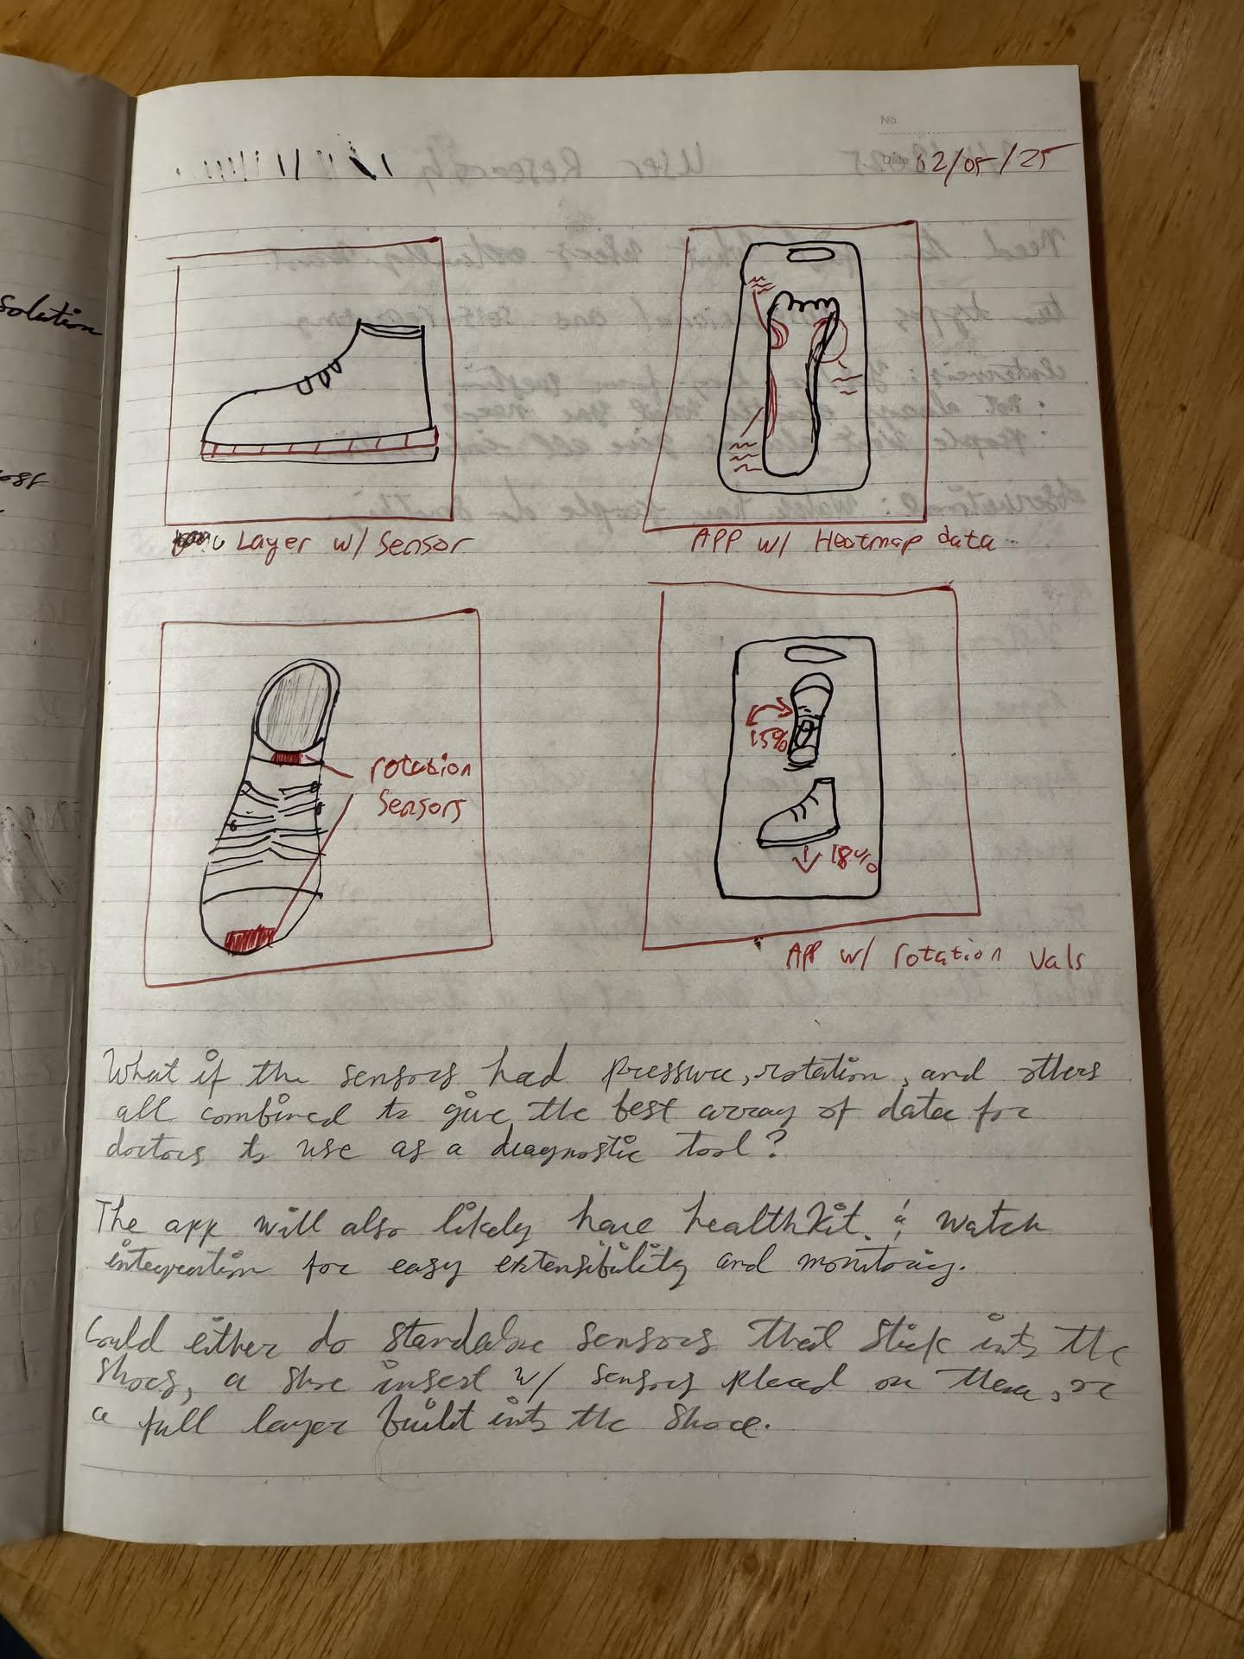
Figure 6. Early Design Sketches and Feedback Brainstorming

Contributions:
Jayme Greer: 50% – helped write this document
Evan Bohler: 16% – helped write this document
Sophia Miller: 18% – read over this document, helped write this document
Charlie Whittleman: 16% - helped write this document

